The Solutions
1. Wind power impact
a) Penetration of wind generation will displace energy produced by large conventional plant, but the ability of this technology to displace capacity of conventional plant will be limited. In a 53GW peak demand system, with installed capacity of wind generation of 15GW, estimate the total amount of conventional plant needed to maintain a 20% capacity margin, assuming that the capacity credit of wind generation is 10%.
[3]

Under the assumed wind capacity credit of 10%, 15GW of wind translates into 1.5GW of capacity of conventional plant. To achieve a 20% capacity margin, the total installed capacity of generation would need to be 53 x1.2 = 63.6GW. Hence the required capacity of conventional plant is 63.6-1.5 = 62.1GW.
[FEEDBACK]
Common mistakes included:
- Some students did not explain the assumption related to the capacity margin
- Some students did not explain the meaning of the capacity credit of wind generation

b) An increased penetration of variable and difficult-to-predict wind power will place an additional duty on the remaining generating plant with respect to the task of balancing supply and demand. What will drive the impact on the amount of various forms of generation reserves?
[3]
Uncertainty in wind forecast becomes a source of additional balancing requirements which can be fairly substantial in magnitude. Wind forecast time scales are important for determining reserve requirements. For time scales from several seconds to a few minutes, the fluctuation of the overall output of wind generation will be small given that there is considerable diversity in outputs of individual wind farms. In these very short (Response) time scales, the dominant variability factor is the potential loss of conventional plant, not fluctuations in wind power. Reserve requirements are concerned with the wind forecast uncertainty over longer time scales of minutes to hours. Wind forecast techniques vary for different time scales. For longer horizons beyond several hours, forecasts based on meteorological information are preferred. For short-term forecasts, up to several hours ahead, such methods are out-performed by various statistical techniques.
[FEEDBACK]
Common mistakes included:
- Some students did not discuss importance of uncertainties in wind forecast across different time scales and the corresponding reserve requirements

c) Discuss the cost implications and key drivers that determine the magnitude of these costs and how reserve requirements may reduce the ability of the system to absorb wind.
[3]
In deciding the composition of system reserve, technical and economic considerations need to be made in selecting reserve options. Options include spinning and standing reserve. Combined cycle gas turbines (CCGT) or coal fired plant synchronized but running part loaded will provide spinning reserve. Generating plant that is not synchronized but it can start within the time scale required is classified as standing. Standing reserve is often provided by open cycle gas turbines (OCGT) or pump storage. Costs of holding spinning reserve include fixed fuel losses associated with start-up and no-load costs during running hours whilst utilisation costs are generally the same as system marginal costs. For storage the holding costs are negligible but utilisation costs are based on pumping costs which consist generally of marginal plant costs, plus losses incurred during the pumping/generation cycle. For gas turbines that provide standing reserve the holding costs are negligible but utilisation costs may be much higher. Synchronised reserve is used to accommodate relatively frequent but comparatively small imbalances between generation and demand while standing reserve will be used for absorbing less frequent but relatively large imbalances. Reserve is allocated in order to meet imbalances between predicted and actual demand and it is beneficial to determine the optimal split between the allocation of spinning and standing reserve for achieving the lowest fuel costs. Fuel costs involve a trade off between the more expensive nature of standing reserve plant and the higher costs involved in running spinning reserve plant part loaded. Furthermore, in a generation system with wind, the allocation of reserve affects the ability of the system to absorb wind generation. A high allocation of spinning reserve requires a large number of generators to run part loaded, therefore delivery of energy accompanies provision of reserve. This “must run” generation leaves less room for utilisation of wind generation.
[FEEDBACK]
Common mistakes included:
- In general, explanation of the cost implications of both types of reserve was not comprehensive

d) It is proposed to connect 15GW of wind power to a power system in which demand varies between a minimum of 21GW and a peak of 53GW. The generation mix of the system is composed of inflexible nuclear plant of installed capacity of 8GW and flexible Combined Cycle Gas Turbine (CCGT) plant with characteristics presented in Table 1.1. We will consider hourly cost of balancing this system during minimum and maximum loading conditions, assuming the output of wind generation of 10GW. In order to cover the uncertainty in wind power output, the system operator decides to schedule 3,200MW of reserve to be provided by part loading synchronised CCGTs.
Assume that 8GW of inflexible nuclear plant will be operating at all times and that CCGT plant emits 0.52 tonnes of CO2 per MWh when operated at full output.
Technology | Rating of the unit  [MW] | Minimum stable generation (MSG)  [MW] | Marginal cost at full output  [£/MWh] | Loss in efficiency when run at MSG  [%]
CCGT | 480MW | 320MW | 70 | 20
Table1.1: Plant characteristics

i) Determine the minimum number of flexible generators that need to run to provide the reserve required and their power output.
[2]
Each CCGT set can provide reserve of 160 MW (=480-320) when at MSG. Thus, 20 generators are required to provide reserve of 3,200MW. Those 20 generators will produce 6,400MW (=20x320) at MSG.

ii) Determine the cost associated with this reserve.
[2]
The cost is the additional cost of running at reduced efficiency which for this generator is an additional 20% fuel burn and a 20% increase in marginal cost.
Cost per hour = 3,200 MW x 70 £/MWh x 20% = 44,800 £/h.
iii) Determine the additional CO2 emitted (due to the need to provide reserve).
[2]
The additional CO2 is the CO2 arising from the 20% additional fuel burn. CO2 emissions per hour = 3,200 MW x 0.52 t/MWh x 20% = 332.8 t/h.
iv) Calculate the amount of wind power that may need to be curtailed in both the minimum and maximum system loading conditions.
[2]
“Must run” CCGTs for reserve produces 6.4GW.
“Must run” nuclear is 8GW.
The minimum system loading conditions of 21 GW less must run generation of 14.4GW (=8+6.4) leaves 6.6GW (=21-14.4) of other generation required.
10GW if wind is available but only 6.6GW required, leaving 3.4GW (=10-6.6) of wind to be curtailed off.
For maximum system loading conditions 53GW: 38.6GW (=53-8-6.4) of generation is required so no wind curtailment is needed.
[FEEDBACK]
Common mistakes included:
- For ii), some students misinterpreted “cost associated with reserve” and therefore carried out incorrect calculations
- For ii), some students misinterpreted “loss in efficiency when run at MSG” as having a marginal cost = the original marginal cost / 0.8
- For iii), some students did not fully understand the meaning of “additional CO2 emitted due to the need to provide reserve” and therefore gave incorrect calculations
- For iv), most of the students answered this question correctly.

e) Determine the change in generation costs and CO2 emissions if demand side response can provide 1.8GW of reserve.
[3]
If demand side response can provide 1.8GW of reserve, the reserve to be provided by CCGTs will be reduced to 1.4GW (=3.2-1.8). And in this case:
Cost per hour = 1,400 MW x 70 £/MWh x 20% = 19,600 £/h
CO2 emissions per hour = 1,400 MW x 0.52 t/MWh x 20% = 145.6 t/h
Then:
Change in cost per hour = 19,600 - 44,800 = -25,200 £/h
Change in CO2 emissions per hour = 145.6 - 332.8 = -187.2 t/h
As a result, the cost will be reduced by 25,200 £/h and CO2 emissions will be reduced by 187.2 t/h if demand side response can provide 1.8GW of reserve.
[FEEDBACK]
Common mistakes included:
- Some students only calculated the cost of reserve and CO2 emission in part e), but did not compare with the ones in part d) related to calculation of changes in cost and CO2 emissions.

2. Flexible appliances and big data
a) What are the main challenges associated with utilising big data in energy systems? Which are the potential users of big data?
[3]
The main challenges associated with big data are how to store, manage, analyse and make use of this information to improve energy system cost efficiency and facilitate decarbonisation at least cost.
[FEEDBACK]
Average score: 2/3 points.
Most students were able to cite the computational issues that arise in the presence of big data but did not mention the challenge of using this information in effective manner to gain insights that can improve cost efficiency, decarbonisation etc.
b) Briefly name three tasks that can be improved by the use of smart-meter data.
[3]
Smart meters can measure residential demand every few minutes. If a DNO can aggregate this data and build a comprehensive database of historical consumption patterns, this data can assist with:
- Prediction of electricity demand
- Design of demand response schemes and Times-of-Use tariffs
- Network planning
[FEEDBACK]
Average score: 1.8/3 points.
Most students were able to name two out of three potential applications. The applications that most students did not mention were forecasting and network planning.
c) Explain how data from Phasor Measurement Units (PMUs) can be used to improve a Transmission System Operator’s (TSO’s) ability to ensure dynamic system stability in real-time.
[4]
Big data analytics can be applied to data gathered from Phasor Measurement Units (PMUs) to carry out large-scale security assessment and improve situational awareness. In particular, historical PMU data contain information on what operating points the operator should anticipate in the future. Simulations of faults can be carried out to identify whether each anticipated operating point is stable or unstable. Machine learning techniques (e.g. Decision Trees) are then used to produce security rules delineating the system’s region of stable operation. These security rules can then be used in real-time to identify whether the current situation could result in a system instability and come up with a control scheme to bring back the system within the region of stable operation.
[FEEDBACK]
Average score: 2.3/4 points.
Most students did mention some basic aspects but very few captured all important steps of how a data-driven workflow would operate (historical data -> anticipated operating points -> simulation to obtain post-fault labels -> use of machine learning to build security rules -> deploy security rule to support real-time system operation). Most students missed some of these steps.
d) Explain how governments aim to decarbonise electricity systems. Which are the resulting challenges for these systems and how can demand flexibility contribute in addressing these challenges?
[4]
Governments aim to decarbonise both generation and demand sectors of electricity systems.
Regarding the generation side, decarbonisation will be achieved through the wide integration of renewable and low-carbon generation sources, such as wind and solar generation. However, these generation sources are characterized by inherent variability and non-controllability. Given that demand is currently largely treated as an inflexible, uncontrollable load, the required flexibility for balancing the system and offering the required ancillary services is solely provided by conventional generators. As the penetration of variable renewable generation increases, these conventional generators will be producing less energy, as absorption of the low-cost and CO2-free production of renewable generators will be prioritized in the merit order. However, they need to remain in the system and operate part-loaded as a back-up energy source and flexibility provider, since renewable generators not only have very limited capabilities to provide system balancing services, but they also make system balancing more challenging. This under-utilization of conventional generation assets implies that the cost efficiency of their operation will reduce. Furthermore, in cases where the flexibility of the conventional generation fleet is not sufficient, the last resort for system balancing lies in curtailing renewable generation. This implies that due to balancing challenges, renewable generation assets with high capital costs are also under-utilized and thus may not achieve their CO2 emissions reduction potential.
At the demand side, traditional technologies used in transport and heat sectors (internal combustion engines and gas / oil fired technologies respectively) are responsible for the emission of a significant portion of the total greenhouse gases. In combination with the ongoing decarbonization of electricity generation, strong motives arise for the electrification of these sectors through the introduction of electric vehicles and electric heating respectively. However, due to the natural energy intensity and temporal demand patterns of transportation vehicles and heating loads, this paradigm change is accompanied by a significant increase of the total electricity demand and an even higher increase in the demand peaks, escalating the need for capital-intensive generation and network investments.
In this setting, flexible demand technologies, enabling temporal redistribution of electricity consumption patterns, can contribute in addressing these challenges by supporting system balancing, and therefore reducing system operating costs in a future with an increased penetration of renewable generation, as well as by limiting peak demand levels, and therefore avoiding capital-intensive investments in generation and network assets.

[FEEDBACK]
Average score: 2.8/4 points.
Failing to mention the electrification of heating and transport sectors as a potentially important aspect of decarbonisation.
Not explaining the idea that increasing renewables do not reduce the need for operational reserves, leading to conventional carbon-intensive units being part-loaded.

e) A simple power system, operating at a three-hour horizon, includes:
- a generator producing power (MW) at hour with a cost function 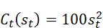 (£) and a maximum output limit 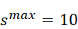MW.
- inflexible demand appliances, consuming power 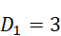MW (at hour 1), 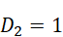MW (at hour 2) and 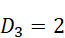MW (at hour 3).
- 1000 identical flexible demand appliances with continuously adjustable power (kW), scheduling interval including hours 1, 2 and 3, total energy required 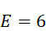kWh and maximum power limit 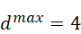kW.
i) Under centralised scheduling, what is the optimal power demand of each of the flexible demand appliances at each of the three hours? What is the total generation cost?
[3]
Total generation must be equal to total demand at each hour, implying:
Due to the quadratic form of the generator’s cost function, the total generation costs are minimised when the generation profile is as flat as possible, or equivalently when:
The sum is minimised.
Combining the above equations means that the objective is:
Minimise 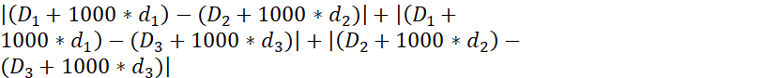
While the operating constraints of the generator and the flexible demand appliances are satisfied:
Generator:
Flexible demand appliances:
This is achieved when kW, kW and kW
The total generation cost is:

ii) Assuming that price-based scheduling is employed, what should be the relation between the prices at hours 1, 2 and 3 (denoted by , and respectively)? What is the resulting power demand of each of the flexible demand appliances? What is the total generation cost? Why is it higher or lower than the total generation cost calculated in i)?
[3]
The relation between the three prices should be ( > > ) in order to incentivise flexible demand appliances to move their demand to off peak hours and flatten the system demand profile.
Each flexible demand appliance aims at minimising its electricity cost. Given that it can acquire its total energy requirements during two hours, it will obtain as much energy as possible at the hour with the lowest price and the rest at the hour with the second lowest price:

kW
kW and
kW

The generator should meet the resulting demand:
MW
MW
MW

The total generation cost is:

The total generation costs are higher than the costs under centralised scheduling. This happens because of the concentration of flexible demand response at the hour with the lowest price.

[FEEDBACK]
Average score: 5/6
Most students were able to answer this question correctly. The few people that failed to get full points was mostly due to some arithmetic error.

3. Reliability models and Monte Carlo analysis
a) The overall reliability of a transformer is modelled as a repairable two-state system and it is evaluated according to failures and repairs occurred in the last 30 years. In the first 15 years, the transformer has failed on average every 2 years and its average repair time has been of 10 days. In the last 15 years, its average operational time has been of 3 years and its average repair time has been of 1 week. What is the mean time between failures (MTBF) of the transformer calculated according to the whole time period of 30 years? If the overall availability of the transformer over the last 30 years is 0.995, what is the corresponding mean time to repair (MTTR)?
[4]
MTBF (for the first 15 years): 2 years = 104 weeks
MTBF (for the last 15 years): (3⋅52)+1=157 weeks
MTBF (for the overall 30 years) = 104 weeks⋅1/2 + 157 weeks ⋅ 1/2= 130.5 weeks
Availability =MTTF/MTBF = (MTBF – MTTR) / MTBF →
- MTTR = (1-Availability)*MTBF = (1-0.995)*130.5 weeks = 0.65 weeks

[FEEDBACK]
Common mistakes included:
- incorrectly considering MTTF (for the first 15 years) = 2 years.
- error in the calculation of the averaged MTBF over 30 years, for example not dividing by 2 the quantities associated to the 15-year periods.

b) Consider a control station of an off-shore wind farm. This is subject to two kinds of faults (hardware and software). In case of a hardware fault (which occurs on average every 300 day), the software components are not compromised. Conversely, when the software components malfunction (which occurs once every 1000 day) also the hardware components fail as a result. The repairs of hardware and software are independent and have the following rates: hardware repair: 1 every 6 hours; software repair: 1 every 24 hours.
i) Draw the continuous Markov chain representing the failure/repair model of the control station, clearly indicating for each discrete state whether the hardware and software components are functioning. Calculate the numerical value of the transition rates in consistent units of measurement.
[3]
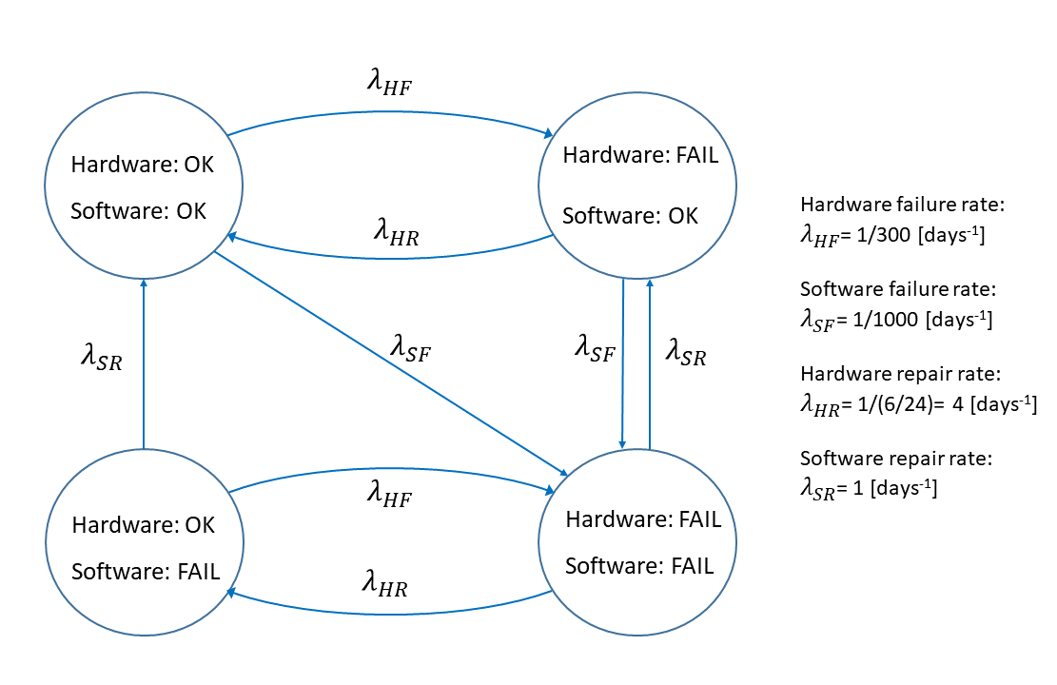
[FEEDBACK]
Common mistakes included:
- not correctly identifying all system states, in particular the (Hardware: OK, software: FAIL) state.
- not including some of the state transitions.

ii) Derive the corresponding discrete-time Markov chain. Provide an analytical expression of the different transition probabilities as a function of time step and transition rates of the continuous Markov chain in point i).
[3]
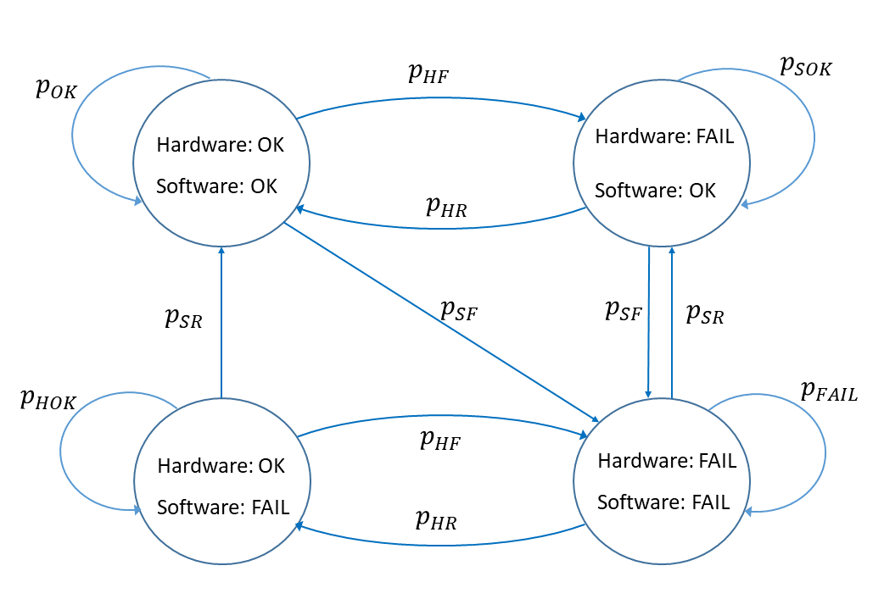

[FEEDBACK]
All students answered this question correctly.

c) A distribution network company operates an Active Network Management scheme (ANM). Such scheme curtails distributed generation (in particular photovoltaic generators) when this is above certain limits and is causing overloading of the lines. The monitoring scheme is implemented through the following components: three sensors (S1, S2, S3) that detect power levels throughout the grid, a processing unit (PU) that determines whether the network conditions require generation curtailment and three actuators (A1, A2, A3) that communicate with different groups of generation units.
The components are independent, with the following availability:
Availability S1 = Availability S2 = Availability S3 = r_{S} = 0.995;
Availability PU = r_{PU} = 0.999;
Availability A1 = Availability A2 = Availability A3 =r_{A}=0.992;
The ANM scheme intervenes in two distinct cases:
- OVERLOAD: distributed generation is slightly above the maximum level. This scenario is only detected if at least two sensors (among S1, S2, S3) are working correctly. In response to the case of OVERLOAD, two actuators are activated by the processing unit PU. These actuators activated by PU need to be working properly and reduce the power generation of their associated generation units. Note that PU chooses the actuators randomly and cannot detect in advance their working/failure state.
- CRITICAL OVERLOAD: distributed generation is significantly above the maximum level. This scenario requires only one working sensor to be detected. In response to the case of CRITICAL OVERLOAD, the processing unit PU will need to activate all actuators, which will then reduce the power generation of their associated generation units.
i) Draw the reliability block diagram for a successful detection and correction of the OVERLOAD scenario. Hint: all actuators have the same availability and therefore are indistinguishable from a reliability point of view.
[3]

S1
S2
S3
2/3
PU
Ax
Ay
Successful detection of the OVERLOAD scenario requires the two actuators chosen by the PU to be working correctly. Since all actuators are equivalent and they are chosen independently of their working/failure state, one can simply assume that two generic actuators (Ax and Ay) are available.

[FEEDBACK]
In some cases, instead of considering two generic actuators (Ax and Ay) in the reliability block diagram, a 2-out-of-3 redundancy of A1, A2 and A3 was assumed.
ii) Draw the reliability block diagram for a successful detection and correction of the CRITICAL OVERLOAD scenario.
[1]
S1
S2
S3
PU
A1
A2
A3

[FEEDBACK]
The question was generally answered correctly. In a few cases, a parallel configuration was erroneously considered for the actuators A1, A2 and A3.

iii) Compute the probability of success for the two cases in point i) and ii).
[2]

[FEEDBACK]
All students answered this question correctly.

d) Let denote the outcome of a random Monte Carlo simulation, i.e. the mean of a finite number n of single sampled states Im_{i}:
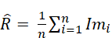
Characterize the random variable that approximates for large values of n. In addition, specify its mean and variance. How does the variance change if m=4n sampled states are considered instead?
[4]

For large values of , the simulation outcome can be approximated as a normal random variable with mean (i.e. the actual value that is being estimated) and variance , where is the number of single sampled states and is the variance in the observation of a single sampled state. When sampled states are considered, the variance is four time smaller.

[FEEDBACK]
Common mistakes included:
- not correctly identifying as normal (or Gaussian) the random variable associated to .
- standard deviation was often incorrectly provided instead of variance.
- when a correct expression of variance was provided, the meaning of the terms and was usually not specified.
- the reduction in variance when was not correctly quantified (for example reporting the reduction in standard deviation or simply stating that variance would be smaller).

4. Quantification of network reliability
a) Provide the definition of a metric used by Ofgem to quantify the reliability of distribution networks. Specify typical values of this quantity in the UK. Provide the definition of system availability as a transmission reliability metric, specifying typical values of this quantity for the GB transmission network.
[3]
Any of the following distribution reliability metrics used by Ofgem can be chosen:
- Customer minutes lost (CML): Duration of interruptions to supply per year. This is the average customer minutes lost per customer per year, where an interruption of supply to customer(s) lasts for three minutes or longer. Typical values: 35-120
- Customer interruptions (CI): This is the number of customers whose supplies have been interrupted per 100 customers per year over all incidents, where an interruption of supply lasts for three minutes or longer, excluding re- interruptions to the supply of customers previously interrupted during the same incident.
Typical values: 25-100
System availability is defined as: percentage of the time that system circuits were available for the transmission of electricity. It is equal to the sum for all circuits of hours available, divided by the product of number of circuits and hours in the considered time period, expressed in percentage. Typical values: 0.90 – 0.99.
[FEEDBACK]
Most students answered this question correctly. However, in some cases “system availability” was not accurately defined or erroneously confused with “reliability of supply”.
b) Consider a section of a distribution network serving 10000 customers. The outage events occurred in one year are reported in Table 4.1.
Customers Affected | Duration
4000 | 30 minutes
300 | 1 day
6000 | 2 minutes
200 | 15 minutes
500 | 8 minutes
20 | 12 hours
150 | 15 minutes
Table 4.1: Outage events
Compute CML and CI for this section of the network.

[3]
Due to the 3-minute minimum requirement for CML and CI, the recorded event that affected 6000 customers for 2 minutes will be excluded from CML/CI calculations.
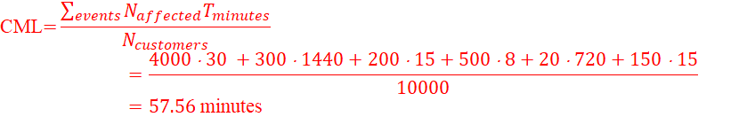
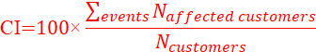
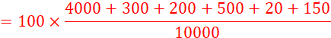
[FEEDBACK]
This question was mostly answered correctly. In a few cases, the factor 100 in the calculation of CI was not included or the fault with duration of 2 minutes was incorrectly considered in the calculations.

c) Consider the distribution network in Figure 4.1.
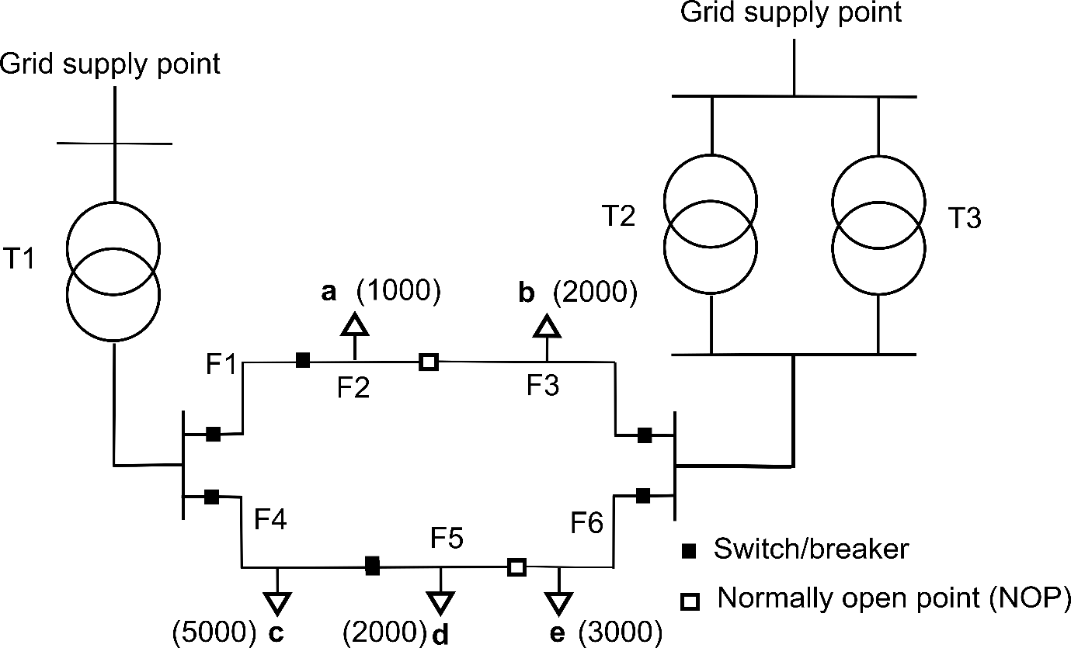
Figure 4.1 Network diagram

The number of customers at each load point (a, b, c, d, e) is reported between brackets in Fig. 4.1. The customers at load points a and b are of industrial type. Each customer at load points a and b has an average power consumption of 3kW and a Value of Lost Load (i.e. interruption cost per unit of lost energy) equal to 25000£/MWh. The customers at load points c, d and e are of residential type. Each customer at these load points has an average power consumption of 0.5kW and a Value of Lost Load (i.e. interruption cost per unit of lost energy) of 8000£/MWh. The availabilities of the transformers (T1, T2, T3) and of the feeders (F1, F2, F3, F4, F5, F6) are reported in Table 4.2. Assume that all components failures are independent and they all last more than three minutes.

Component | T1 | T2 |  | T3 |  | F1 |  | F2
Availability | 0.9997 | 0.9995 |  | 0.9995 |  | 0.9992 |  | 0.9995
Component | F3 |  | F4 |  | F5 |  | F6
Availability | 0.9998 |  | 0.9997 |  | 0.9995 |  | 0.9994
Table 4.2 Availability parameters
The capacity of T1 is always sufficient to serve loads at point a, c and d. Transformers T2 and T3 are redundant, as their individual capacity (of a single transformer) is always sufficient to serve all customers at load points b and e. The network is radially operated but the normally open points (NOPs) between F2 and F3 and between F5 and F6 can ensure some redundancy. They can be closed to resupply load points a and d in case of faults in the left-hand side of the network diagram. This operation is performed only if both transformers T2 and T3 are working. Note that the NOPs are not used to resupply load points other than a and d.
i) Calculate the probability that each load point is connected to a grid supply point (one expression for each load point).
[5]
Let p(x) denote the availability of component x and P(X) the probability that customers at load point X are connected to a grid supply point. The probabilities of each component being connected to a grid supply point are the following:
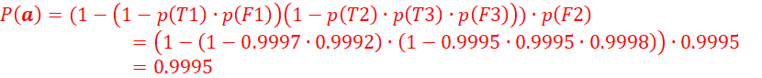

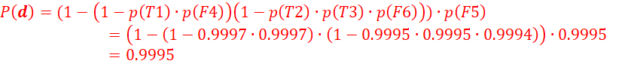

[FEEDBACK]
All students provided correct expressions for , and. In some cases, the effect of the NOPs was not properly taken into account, leading to incorrect calculations of and.

ii) Compute the expected CML and the expected annual cost of interruptions for this network.
[4]

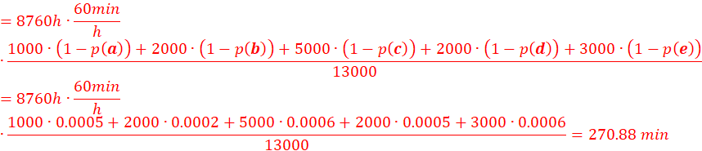

The expected customer interruption cost for an industrial customer at load point X (either a or b) is given by:
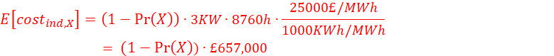

The expected customer interruption cost for a residential customer at load point Y (either c, d or e) is given by:
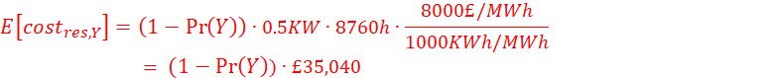
The total expected cost corresponds to:

[FEEDBACK]
The calculations for the expected CML were generally correct. Occasional mistakes were made in the calculation of the expected annual cost of interruptions, with incorrect time rescaling or numerical errors.

iii) Is it possible to quantify the expected annual value of the Normally Open Points on the basis of the results of points i) and ii) or is it necessary to perform additional analyses of a similar kind? If this is the case, provide a general description of the procedure to be followed (actual calculations are not required).
[2]
The expected annual value of the Normally Open Points (NOPs) can be quantified as the difference between the expected costs of the system when NOPs are not considered (and the costs of the system when NOPs are used to resupply the load points a and d in case of faults (:

.
The calculation of therefore requires , which has been derived at the previous point and , which can be calculated by repeating the calculations of points i) and ii) excluding the possibility of using the NOPs to resupply the load points a and d after a fault.

[FEEDBACK]
This question was mostly answered correctly. In some cases, it was erroneously stated that calculations of the expected annual value of the NOPs were not possible or required Monte Carlo simulations.

iv) Customer Interruption Costs represent a crucial concept in the evaluation of network reliability.
- Discuss the main factors that can impact Customer Interruption Costs and provide some examples.
- What are the main methods to measure Customer Interruption Costs?
[3]
The main factors that can significantly impact Customer Interruption Costs are:
- Customer type. The interruption costs will be different for residential, industrial and commercial customers. For example: the interruption costs of a large industrial user will in general be greater than the ones of a residential customer.
- Time of interruption. The cost of an interruption depends in general on the time at which it occurs. For example: the interruption costs for a factory will be higher during its working hours, as production might have to be interrupted.
- Duration of interruption. Longer interruptions will tend to be more costly.
- Frequency of interruption. Repeated interruptions over a short amount of time will in general be more costly.

The main methods to measure Customer Interruption Costs are:
- Economic analysis. The productivity/welfare associated with loss of a unit of energy is estimated.
- Blackout case studies. The costs actually incurred in previous interruptions are considered.
- Surveys. The costs are estimated by conducting surveys on customers.

[FEEDBACK]
Answers to this question were generally correct. In some cases, the reliability of the system components was erroneously considered as a relevant factor impacting Customer Interruption Costs.

